Make a joyful noise, all the earth! Break forth in joyous song to the God of Victory! Let the sea roar and all that fills it; the world and those who dwell in it. With trumpets and the sound of the horn we will make a joyful noise as we worship God.

BETHANY PRESBYTERIAN CHURCH
MEMORIAL ASSOCIATION
67th HOMECOMING SERVICE
SUNDAY, JUNE 10, 2018

ORDER OF WORSHIP

Prelude & Olde Tyme Hymn Sing Nancy Jean Roberts
Welcome from the Association President J. Warren Haupt
Call to Worship Rev. Edson S. Pederson
Invocation
*Hymn: “Love Divine, All Loves Excelling” Hymn No. 339
* The Apostles’ Creed Page 12 in Hymnal
* The Gloria Hymn No. 546
Responsive Reading #9 Page 476 in Hymnal
Announcements Rev. Pederson
Prayers of the People and The Lord’s Prayer Rev. Pederson
(debts and debtors)

Offering for support of Bethany Memorial Association

* “Praise God from Whom All Blessings Flow” Hymn No. 544
*Hymn: “More Love to Thee, O Christ”” Hymn No.397
Scripture: John 4:7-9 Rev. Pederson
SERMON: God Defines Love Rev Pederson
*Hymn: “Jesus Thou Boundless Love” Hymn No. 404
Closing prayer Rev. Pederson
*Verse 1 “Blest Be the Ties That Bind” Hymn No. 473
* The Congregation will please stand
We are pleased to once again welcome the Reverend Edson S. Pederson, Temporary Supply at Bethany, as our Homecoming speaker. Born in Seattle, Washington, Edson graduated from the University of Washington and Princeton Theological Seminary. For 16 years he served pastorates in Washington, Oregon and Idaho before moving to Richmond in 1980. He retired from teaching history and earth sciences at J. R. Tucker High School in 2003 and currently enjoys being a certified Richmond Tour Guide for The Valentine Museum. We extend a cordial welcome to Edson and his wife, Sharon Larkins-Pederson. They were married at Bethany on October 9, 1999.

Our Pianist is Nancy Jean Roberts. A graduate of New Kent High School and Madison College (now JMU), she served 4 years as an Air Force Officer. Her musical talents include choir, handbells, soloist, flutist, accompanist, director, organist and pianist. We are grateful she agreed to follow in the steps of her Mother, Elizabeth Roberts, who was Bethany pianist for many years.

The flowers in the Sanctuary today are given to the glory of God and in memory of Ann Adams Johnson and William Dale Johnson.

Officers of the Association

J. Warren Haupt, President Ray Goodloe, Vice President
Anne B. Crom, Treasurer

It is with sadness we report the loss of the following members since our last meeting:

Edward Ladd Adams
DOB : April 5, 1930 DOD: August 25, 2017

Juliet Louise Walls
DOB: Aug.30. 1948 …………..DOD: Oct. 31, 2017

Ann Adams Johnson
DOB Jul 21 1944 DOD May 23 2018

Charles Edward Haupt
DOB Sep 28 1940 DOD May 16 2018

“Give to the departed eternal rest and may light perpetual shine upon them.”

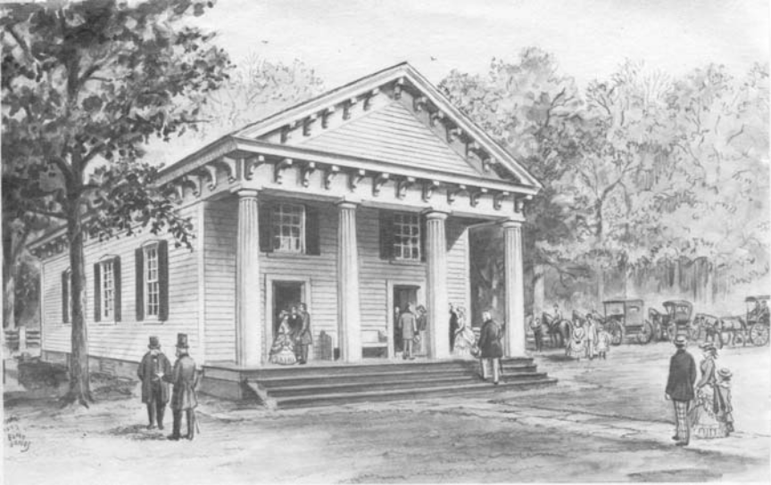

Bethany Presbyterian Church

Charles City, Virginia

The Memorial Association
69th Homecoming Service

Reverend Edson S. Pederson
Guest Speaker

June10, 2018

Whosoever thou are that enters this church, remember it is the house of God; enter it not without the spirit of reverence and leave it not without one prayer to God for thyself, for those who minister, and those who worship here.

